Left-Truncatable Primes
# Source: AI Source: Provided by: [Data Path: Persons Table -> ID Column: 1, Name_En Column: Motasem Essam] -> From: [ChatGPT] on [7/13/2026]
A left-truncatable prime is a prime number that remains prime after repeatedly removing its leftmost digit, one digit at a time.
For example,
$$317$$
is a left-truncatable prime because
$$317→17→7,$$
and every resulting number is prime.
Left-truncatable primes are studied in number theory, digit patterns, and computational mathematics.

Definition
# Source: AI Source: Provided by: [Data Path: Persons Table -> ID Column: 1, Name_En Column: Motasem Essam] -> From: [ChatGPT] on [7/13/2026]
A left-truncatable prime is a prime number that remains prime after repeatedly removing the leftmost digit until only a single digit remains.
The original number must also be prime.

Rules for Left-Truncatable Primes

1. The Original Number Must Be Prime
# Source: AI Source: Provided by: [Data Path: Persons Table -> ID Column: 1, Name_En Column: Motasem Essam] -> From: [ChatGPT] on [7/13/2026]
The starting number must be prime.
Example
$$317$$
is prime.

2. Remove One Leftmost Digit at a Time
# Source: AI Source: Provided by: [Data Path: Persons Table -> ID Column: 1, Name_En Column: Motasem Essam] -> From: [ChatGPT] on [7/13/2026]
At each step, remove only the leftmost digit.
Example
For
$$317,$$
the truncation sequence is
$$317→17→7.$$

3. Every Truncated Number Must Be Prime
# Source: AI Source: Provided by: [Data Path: Persons Table -> ID Column: 1, Name_En Column: Motasem Essam] -> From: [ChatGPT] on [7/13/2026]
Every number obtained during the truncation process must be prime.
Example
For
$$617,$$
the truncations are
$$617, \\ 17, \\ 7.$$
Since all are prime,
617 is left-truncatable.

4. Stop When One Digit Remains
# Source: AI Source: Provided by: [Data Path: Persons Table -> ID Column: 1, Name_En Column: Motasem Essam] -> From: [ChatGPT] on [7/13/2026]
Continue truncating until only one digit remains.
The final digit must be one of
$$2, 3, 5, 7.$$

5. Leading Zeros Are Ignored
# Source: AI Source: Provided by: [Data Path: Persons Table -> ID Column: 1, Name_En Column: Motasem Essam] -> From: [ChatGPT] on [7/13/2026]
If truncation creates leading zeros, they are ignored.
Example
For
$$103,$$
the truncations are
$$103→03=3.$$
Although $3$is prime, the original number
$$103$$
is not left-truncatable because the intermediate number 03 is not considered a valid decimal representation in the standard definition. Standard constructions avoid leading zeros.

6. Left-Truncatable Primes Can Contain Even Digits
# Source: AI Source: Provided by: [Data Path: Persons Table -> ID Column: 1, Name_En Column: Motasem Essam] -> From: [ChatGPT] on [7/13/2026]
Unlike circular primes, left-truncatable primes may contain even digits or the digit 5, because those digits are not necessarily the final digit of every truncation.
Example
$$283$$
contains an even digit, although it is not left-truncatable for other reasons.

7. There Are Exactly 4,260 Left-Truncatable Primes (Base 10)
# Source: AI Source: Provided by: [Data Path: Persons Table -> ID Column: 1, Name_En Column: Motasem Essam] -> From: [ChatGPT] on [7/13/2026]
Unlike ordinary primes, the set of left-truncatable primes in base 10 is finite.
There are exactly
$$4260$$
left-truncatable primes.
The largest has 24 digits.

First Left-Truncatable Primes
# Source: AI Source: Provided by: [Data Path: Persons Table -> ID Column: 1, Name_En Column: Motasem Essam] -> From: [ChatGPT] on [7/13/2026]
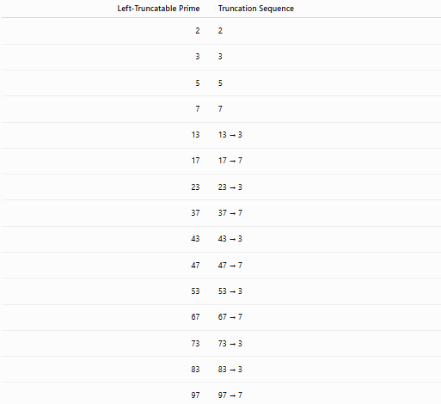
Left-Truncatable Prime | Truncation Sequence
2 | 2
3 | 3
5 | 5
7 | 7
13 | 13 → 3
17 | 17 → 7
23 | 23 → 3
37 | 37 → 7
43 | 43 → 3
47 | 47 → 7
53 | 53 → 3
67 | 67 → 7
73 | 73 → 3
83 | 83 → 3
97 | 97 → 7

Examples
# Source: AI Source: Provided by: [Data Path: Persons Table -> ID Column: 1, Name_En Column: Motasem Essam] -> From: [ChatGPT] on [7/13/2026]
Example 1
Determine whether
$$317$$
is a left-truncatable prime.
Truncations:
$$317→17→7.$$
All numbers are prime.
Therefore,
317 is a left-truncatable prime.

Example 2
Determine whether
$$617$$
is a left-truncatable prime.
Truncations:
$$617→17→7.$$
All are prime.
Therefore,
617 is a left-truncatable prime.

Example 3
Determine whether
$$239$$
is a left-truncatable prime.
Truncations:
$$239→39.$$
Since
$$39=3×13,$$
239 is not left-truncatable.

Example 4
Determine whether
$$3797$$
is a left-truncatable prime.
Truncations:
$$3797→797→97→7.$$
Every number is prime.
Therefore,
3797 is a left-truncatable prime.

Example 5
Determine whether
$$593$$
is a left-truncatable prime.
Truncations:
$$593→93.$$
Since
$$93$$
is composite,
593 is not left-truncatable.

Example 6
Determine whether
$$73$$
is a left-truncatable prime.
Truncations:
$$73→3.$$
Both numbers are prime.
Therefore,
73 is a left-truncatable prime.

Common Left-Truncatable Primes
# Source: AI Source: Provided by: [Data Path: Persons Table -> ID Column: 1, Name_En Column: Motasem Essam] -> From: [ChatGPT] on [7/13/2026]
Some well-known left-truncatable primes are
$$13, \\ 17, \\ 23, \\ 37, \\ 43, \\ 47, \\ 53, \\ 67, \\ 73, \\ 83, \\ 97, \\ 317, \\ 617, \\ 3797.$$

How to Determine Whether a Number Is a Left-Truncatable Prime
# Source: AI Source: Provided by: [Data Path: Persons Table -> ID Column: 1, Name_En Column: Motasem Essam] -> From: [ChatGPT] on [7/13/2026]
- Verify that the original number is prime.
- Remove the leftmost digit.
- Test the resulting number for primality.
- Repeat until one digit remains.
- If every number is prime, the number is a left-truncatable prime.
Example
Check
$$617.$$
Truncations:
$$617→17→7.$$
All are prime.
Therefore,
617 is a left-truncatable prime.

Real-Life Applications
# Source: AI Source: Provided by: [Data Path: Persons Table -> ID Column: 1, Name_En Column: Motasem Essam] -> From: [ChatGPT] on [7/13/2026]
Left-truncatable primes are primarily used in:
- Number theory research
- Computational mathematics
- Prime number searches
- Primality testing
- Algorithm development
- Mathematical software
- Computer science
- Mathematics education
- Recreational mathematics
- Research in digit-based prime patterns

Real-Life Examples
# Source: AI Source: Provided by: [Data Path: Persons Table -> ID Column: 1, Name_En Column: Motasem Essam] -> From: [ChatGPT] on [7/13/2026]
1. Number Theory Research
Researchers study left-truncatable primes to understand how deleting leading digits affects primality.

2. Computational Mathematics
Recursive algorithms generate left-truncatable primes by adding digits to the left while preserving primality.

3. Prime Number Searches
Computer programs enumerate all left-truncatable primes and verify the complete set.

4. Mathematical Software
Computer algebra systems automatically perform repeated left truncations and primality tests.

5. Recreational Mathematics
Left-truncatable primes are popular examples of unusual digit-based properties of prime numbers.

6. Mathematics Education
They illustrate the interaction between decimal notation and prime-number properties.

Common Mistakes
# Source: AI Source: Provided by: [Data Path: Persons Table -> ID Column: 1, Name_En Column: Motasem Essam] -> From: [ChatGPT] on [7/13/2026]
- Confusing left-truncatable primes with right-truncatable primes.
- Removing digits from the wrong side.
- Forgetting to test the original number.
- Removing more than one digit at a time.
- Assuming every truncatable prime is two-sided.

Key Points
# Source: AI Source: Provided by: [Data Path: Persons Table -> ID Column: 1, Name_En Column: Motasem Essam] -> From: [ChatGPT] on [7/13/2026]
- A left-truncatable prime remains prime after repeatedly removing the leftmost digit.
- Every intermediate number must be prime.
- The process stops when a single-digit prime remains.
- In base 10, there are exactly 4,260 left-truncatable primes.
- The largest left-truncatable prime has 24 digits.
- Left-truncatable primes are finite in base 10.

Left-Truncatable Primes vs. Right-Truncatable Primes
# Source: AI Source: Provided by: [Data Path: Persons Table -> ID Column: 1, Name_En Column: Motasem Essam] -> From: [ChatGPT] on [7/13/2026]
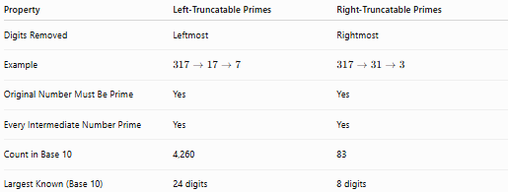
Property | Left-Truncatable Primes | Right-Truncatable Primes
Digits Removed | Leftmost | Rightmost
Example | $$317→17→7$$ | $$317→31→3$$
Original Number Must Be Prime | Yes | Yes
Every Intermediate Number Prime | Yes | Yes
Count in Base 10 | 4,260 | 83
Largest Known (Base 10) | 24 digits | 8 digits

Conclusion
# Source: AI Source: Provided by: [Data Path: Persons Table -> ID Column: 1, Name_En Column: Motasem Essam] -> From: [ChatGPT] on [7/13/2026]
A left-truncatable prime is a prime number that remains prime after repeatedly removing its leftmost digit, one digit at a time, until only a single-digit prime remains. Unlike two-sided truncatable primes, which are extremely rare, there are exactly 4,260 left-truncatable primes in base 10, with the largest containing 24 digits. Left-truncatable primes are an important family of digit-based prime numbers studied in number theory, computational mathematics, and recreational mathematics. They provide insight into how decimal digit deletion interacts with the fundamental property of primality.

